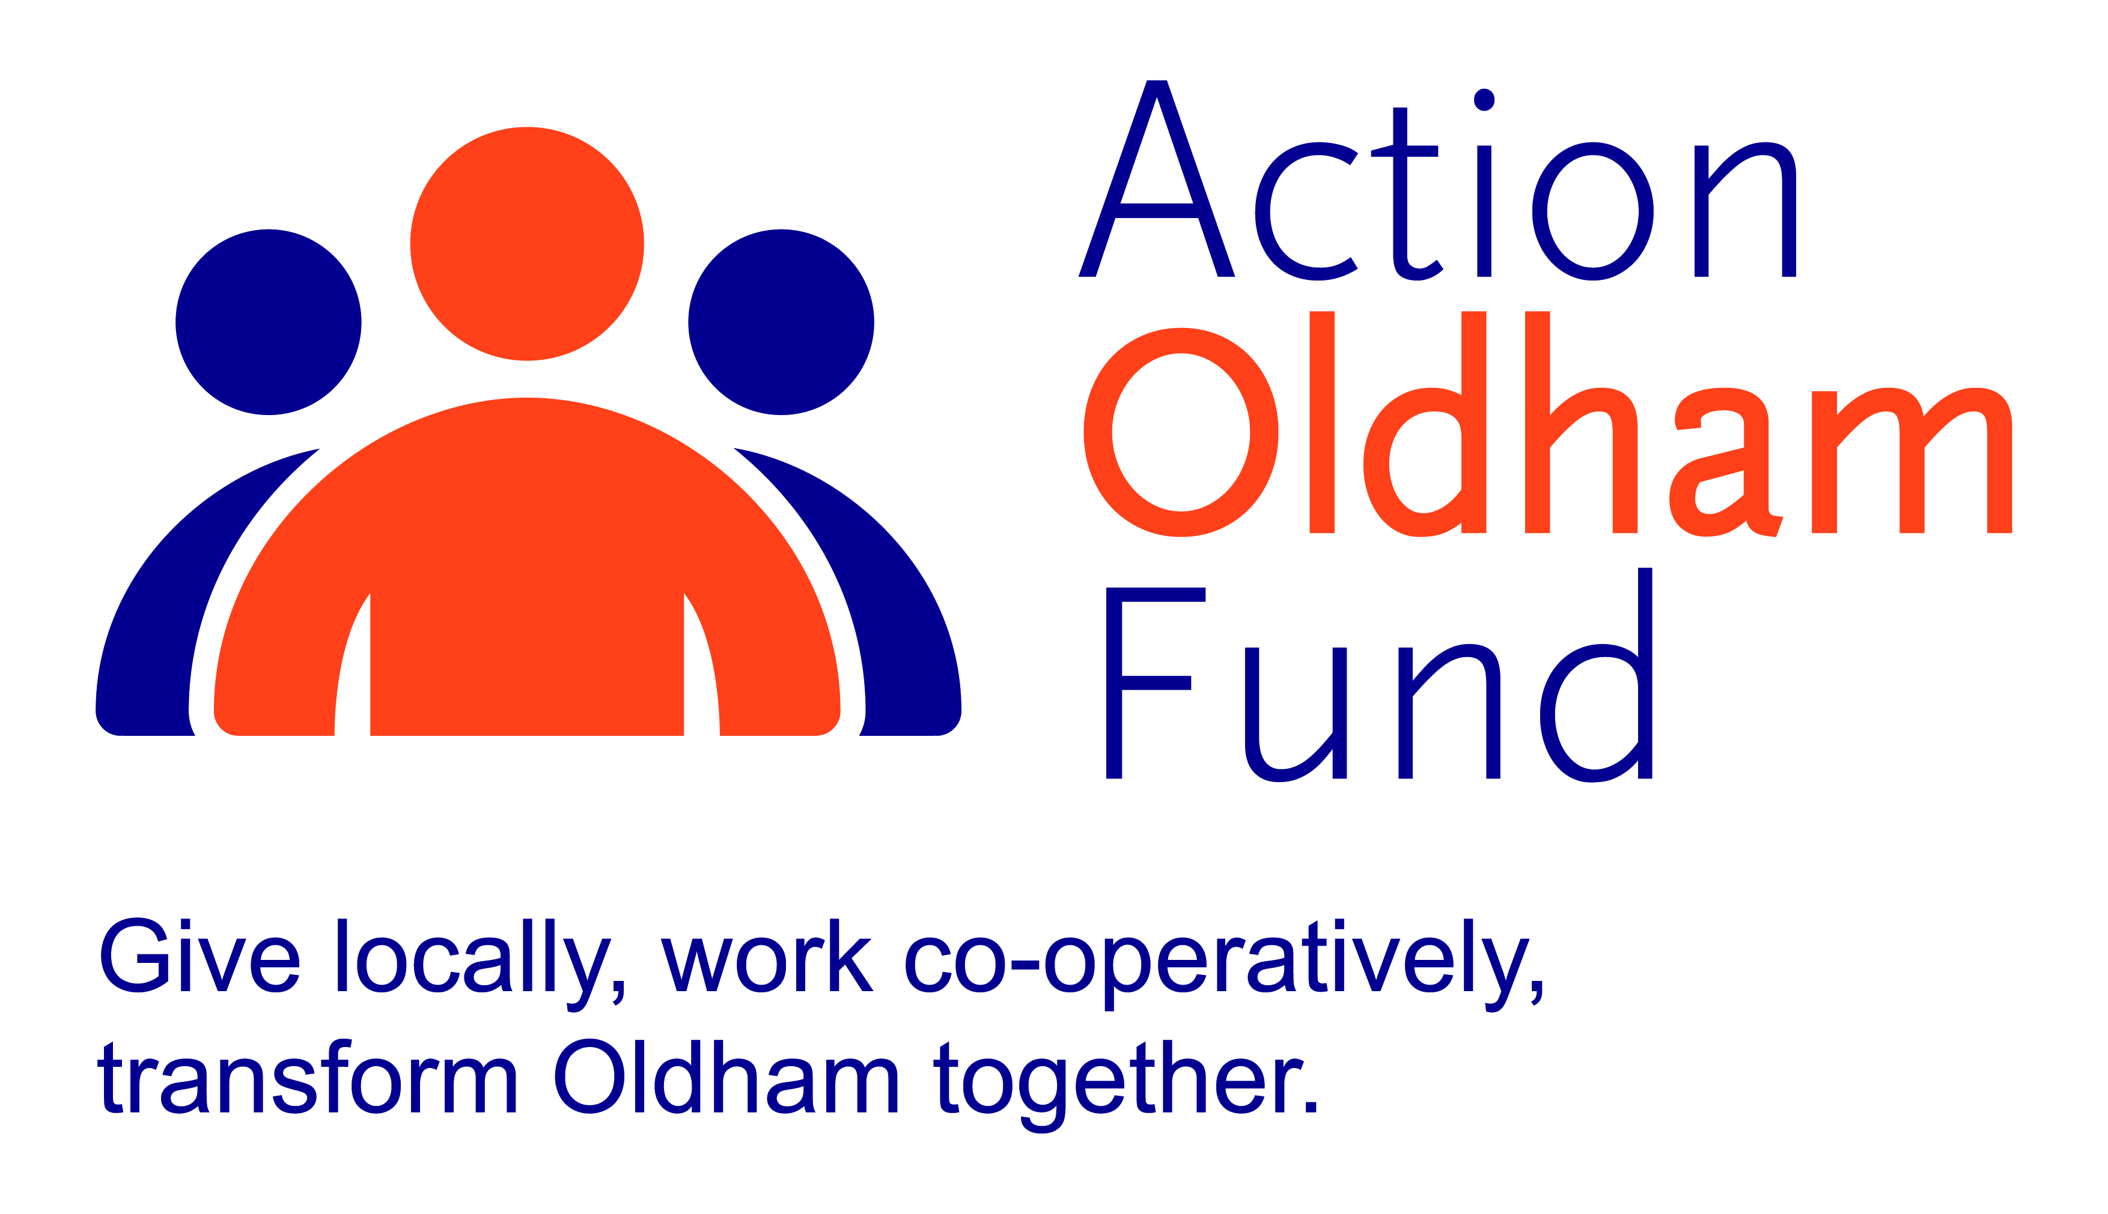

Action Oldham 2017 Seedcorn

For funding upto £1,000

Thank you for your interest in doing your bit to help make Oldham a place where co-operative action makes a real and lasting difference to the lives of local people. The Action Oldham Project Fund is made available through the generous contributions of local people, businesses, and local partners. The Fund and its grant scheme is managed and administered by Action Together and an independent grants panel is responsible for making decisions on funding awards.

Eligibility
Funding will only be given to groups and organisations:
- based or working in the area of Oldham Borough Council and beneficiaries must be Oldham Borough residents
- committed to supporting the principles of equality and diversity, consistent with the policies of Action Together
- who are founded on charitable principles where people have come together to take action for the benefit of local communities rather than for financial gain
- who have a written constitution that outlines how its affairs are managed and all profits are reinvested in their social purpose

Funding will only be given to groups and organisations that have an evidenced income of less than £500,000 a year and organisations who have received Action Oldham Seedcorn funding from last year's allocation may apply for Action Oldham Project funding in this current year.

- Organisations who received Action Oldham Seedcorn or Project funding from last year’s allocation are excluded from applying in this current year.

Priorities for Action Oldham Fund 2017
Working with Oldham residents helping them to make to most of their strengths and assets:
- supporting them to make long term improvements to their lives by enhancing skills (projects that support or encourage local people into work or volunteering, for example: confidence building projects, skill building programmes; self-esteem workshops.)
- supporting them to make long term improvements to their wellbeing (projects that improve physical or mental health and wellbeing, for example: starting an exercise or walking group, reading groups, workshops on health awareness projects.)
- supporting them to realise their visions and make long term improvements to their communities (projects that help communities and groups become more sustainable, for example fitting of new flooring enabling a room to be rented out, help towards innovative ideas for marketing and promoting your community asset or development of volunteers and paid staff)

The Fund particularly wants to support projects that wish to experiment with new ideas and new approaches to developing opportunities.

Exclusions
We will not fund:
- individuals
- social enterprises and organisations trading for profit or intending to redistribute grant awards
- statutory organisations, such as local authorities, schools and the police force
- projects seeking to promote religious or political views, or to exclusively benefit members of religious or political groups
- retrospective costs (projects/activities that are already taking place, have taken place or have been paid for)
- projects where the majority of the activity takes place outside of the Borough of Oldham
- overseas travel or activities
- contributions to larger/major appeals

If you need advice or support to complete your application form, please contact one of our development team on 0161 339 2345 who will be happy to discuss your project or idea.

Objectives & Principles
We particularly welcome projects which address one or more of the objectives and principles of the Fund:
Objectives:
- Enable local communities to identify and implement local solutions to local problems, and provide appropriate support
- Promote voluntary social action and a culture of volunteering
- Promote co-operation and collaboration within and between communities
- Promote equality of opportunity and inclusion

Principles:
- Sustainability – Action Oldham Fund should be replenished from a series of sources, which includes interest accruing from investment of dormant trust fund monies; and fund-raising activities; Contributions from donors or others.
- Innovation and making a difference – Action Oldham Fund will seek to support, where possible, projects that wish to experiment with new ideas and new approaches to familiar problems.
- Added value – Action Oldham Fund will seek to add value, for example by offering match-funding to unlock bigger investments for Oldham.

Completing the application form
- Please ensure that ALL boxes on this form are completed.
- Guidance notes are included with the questions.
- A number of questions state a specific word count, all words over this number will be deleted before submission to the grants panel.
- To avoid any delays in processing your application we ask you to include all the additional information that is requested in the checklist at the end of this form. Incomplete applications or those which do not include the correct supporting documentation will not be submitted to the panel.
- Applications must be received by email. Supporting information can be posted but must be with Action Together by the deadline date.
- The deadline for applications is Friday 3 November 2017, 12 noon. Late submissions will not be accepted.
- Successful applicants will be informed of the panel’s decision within 1 month of the deadline date.
- When your application form is complete, please return to grants@actiontogether.org.uk
- Please put “Action Oldham Fund Grant Application” and the name of your organisation in the subject field of your email.

If you have any queries about the application form or application process, please contact the development team on:

Telephone: 0161 339 2345 Email: development@actiontogether.org.uk

ACTION TOGETHER CIO Charity Registration Number: 1165512

OFFICE USE ONLY
Date Received | Name of Applicant

Please complete the application form below. Typed text must be Arial font 12 and each answer must be no more than 400 words.

Part 1 | Name of Project
Q1 | What is your idea and how does it fit into the overall aims and objectives of your organisation? We would like to know how you got the idea for this project, who will be running it and are the proposed beneficiaries involved in the designing of it? What, where and when will the activities take place? Who are your beneficiaries and why?  We also want to know how this fits in to the organisation’s overall aims and objectives.
Q2 | When will your project start and end? (The start date should be at least one month after the deadline date for applications; the end date should be within one year of the start date.)
 | Start date: ……………………….. End Date: ………………………..
Q3 | Which of the funding priorities for 2017/18 does your project fit into? (Your project must meet one of the priorities listed to be considered for funding. Please only tick one box)
- supporting them to make long term improvements to their lives by enhancing skills (projects that support or encourage local people into work or volunteering, for example: confidence building projects, job clubs, skill building programmes; self-esteem workshops.)

- supporting them to make long term improvements to their wellbeing (projects that improve physical or mental health and wellbeing, for example: starting an exercise or walking group, reading groups, workshops on health awareness projects.)

- supporting them to realise their visions and make long term improvements to their communities (projects that help communities and groups become more sustainable, for example fitting of new flooring enabling a room to be rented out, help towards innovative ideas for marketing and promoting your community asset or development of volunteers and paid staff)

Q4 | What differences/changes/outcomes do you expect to happen as a result of this project for the organisation and how will you prove this? (Please explain in detail the results, difference or change you intend for your project to have on your organisation.) For example, have you attracted further funding, taken on new members of staff increased the skills and knowledge of existing staff and volunteers.
Q5 | What changes/outcomes do you expect to happen as a result of this project for the beneficiaries and how will you prove this? (Please explain in detail the results, difference or change you intend for your project to have on the local community or target beneficiaries.)  For example, the expected outcomes for users of a refugee centre might include improved English language skills, improved confidence in accessing services and reduced isolation.
Q6 | How will you ensure that your proposed beneficiaries know about this project and are able to get involved? We want to know how you will ensure that people from different backgrounds are involved, know about your project and benefit from it? If there are particular groups who could benefit but are less likely to take part, explain why this is the case and what you will do to tackle it. If your project will involve the wider community, tell us how. Please also outline your organisation’s commitment to equality and diversity and how you ensure this within your service delivery. How do you ensure your service is accessible on a day to day basis? (i.e. accessible to people with disabilities / accessible to people living in different parts of the borough / accessible at different times of the day).

Part 2
Q7 | Contact details
Name of organisation
Your name
Your telephone number
Your mobile number
Your email address
Address details (inc post code)
Q8 | What type of organisation are you? (please tick) (Applicants must fall in to one of the following categories: Community groups, voluntary organisations, registered charities, the community work of faith groups, social enterprises and community interest companies, where there is accountability to the public via a board of trustees or to a membership and where all profits are reinvested in the social purpose of the organisation.)
 Registered Charity - Number: .........................
 Not for profit Company - Number: …………....…
 Community Interest Company - Number: ……………
 Community Group/Club/Society
 Other (Please explain) .....................................................………………………..

Q9 | When did your organisation start? Please give date: ............... (dd/mm/year)
Q10 | Has your organisation got its own bank account?
Q11 | Are your staff / volunteers appropriately DBS checked?
Q12 | Which of the following do you have in place? (Please tick all that apply)
Health and Safety (incl. risk assessment) policy
Safeguarding Children policy
Safeguarding Vulnerable Adults policy
Volunteering policy
Equality and Diversity (statement or policy)
Public Liability Insurance
Up-to-date Annual Accounts

Q13 | Please state your organisation’s turnover for the last financial year £
Q14 | Please indicate how much money you need and what it will be used for:
Budget heading |  |  |  |  |  |  | Amount £
1
2
3
4
5
Total amount requested from the Action Oldham Seedcorn Fund |  |  |  |  |  |  | £
Total cost of project |  |  |  |  |  |  | £
If relevant where is the rest of the money coming from?

Have you got this match funding in place already?
Q15 Action Oldham Fund Fundraising
This grant comes from the Action Oldham Fund, a project designed to drive local giving in the form of cash donations, personal and professional time and skills or the donation of physical resources. The team at Action Oldham Fund organises fundraising events and promotes the fund to support financial giving from individuals, businesses and local partners. All money raised goes into this fund and is distributed to local charities through Action Oldham grants.

We want the scheme to be sustainable so that it can continue to benefit communities across Oldham in future years. Therefore, all groups receiving funding from the Action Oldham Fund will be asked to do their bit in return.

Please tell us how you will support the sustainability of this fund and how you will help to support the various fundraising activities of Action Oldham. For example, you could take on a sponsored challenge event such as parachute jump, support and attend our fundraising dinners, offer raffle prizes or volunteer your facepainting skills for an event.

Action Together’s website, actiontogether.org.uk, has details of forthcoming fundraising campaigns. Alternatively, please contact us here at Action Together for further examples of how you could give back.

Part 3 | Declaration
I confirm that the details on this application form are correct.

I am authorised to apply for this money on behalf of my organisation.

N.B. We require two signatures from people who are not related to each other or share the same household and are authorised to sign on behalf of your organisation. There must be at least one signatory from the governing body (e.g. management committee / board of trustees).
Scanned signatures are acceptable.
Person 1 |  |  |  | Person 2
Name |  |  |  | Name
Role |  |  |  | Role
Signature |  |  |  | Signature
Date |  |  |  | Date
Please return the completed application by email to grants@actiontogether.org.uk before Friday 3 November 12 noon.

Don’t forget to put “Action Oldham Fund Grant Application” and the name of your organisation in the subject field of your email.

